46

Ticket Service App

Database, Interface and Report Design

Version 1.0

30.08.2021

Patrick Ilunga Kabemba

Revised History

|  |  |  |  |  |
| --- | --- | --- | --- | --- |
| **Date** | **Description** | **Author** | **Comments** | |
| 31.08.2021 | Version 1.0 | Patrick Ilunga | |  |
|  |  |  | |  |
|  |  |  | |  |
|  |  |  | |  |

**Document Approval**

Software Interface, and Functional Analysis Document have been Followed and Approved by:

|  |  |  |  |
| --- | --- | --- | --- |
| **Signature** | **Name** | **Title** | **Date** |
|  |  |  |  |
|  |  |  |  |
|  |  |  |  |

**Contents**

**Document Approval ii**

**1. INTRODUCTION one**

1.1 Purpose one

1.2 Scope one

**2. REQUIREMENTS one**

2.1 External Interface Requirements one

2.1.1 Main screen one

2.1.2 Other Screens one

2.2 General functions one

2.2.1 Tools to be used one

**1. INTRODUCTION**

**1.1 Purpose**

*Ticket Service Module to make an Interface, Database and Functionality analysis document that will support the minimum requirement document.*

**1.2 Scope**

* *Creating the Ticket Service Module program interface design.*
* *To design the Ticket Service Module reporting interface.*
* *Creating the functionality design of the program to be designed*

**2. REQUIREMENTS**

**2.1 External Interface Requirements**

**2.1.1 Main Screen**

Login to ticket service app if already registered or go to registration page.

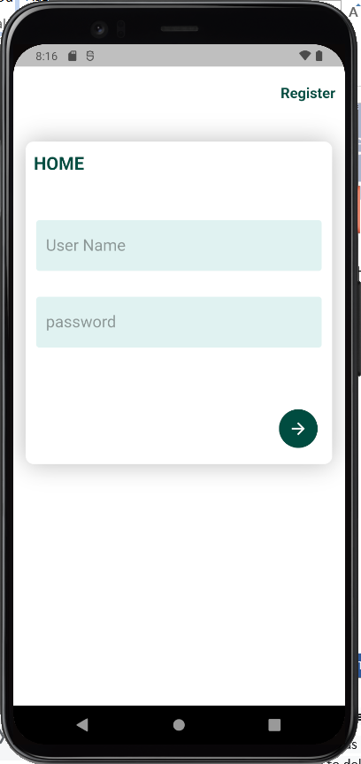

**2.1.2 Other Screens**

**2.1.2.1 Registration Screen**

* **Create a new account providing user name, name, email address and password**
* **Return to login page if already registered**

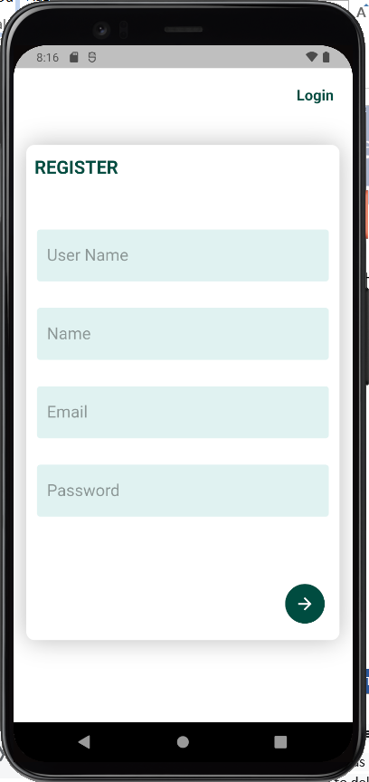

**2.1.2.2 Requests Screen**

* **View all requests, pending and resolved ones**
* **Filter requests**
* **Access Drawer where we can find others links to add request, settings, contact pages and logout button**

**2.1.2.3 Add Request Screen**

* **Create a new request by providing level, full name, phone, type, Description**
* **Attach file to request**

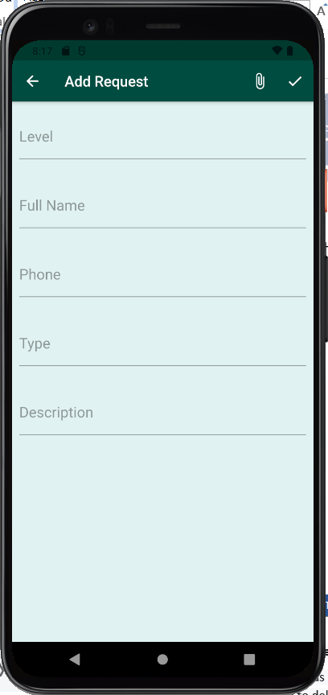

**2.1.2.4 View request Screen**

* **Open request**
* **View details of request**
* **See Technician appointed to that request**

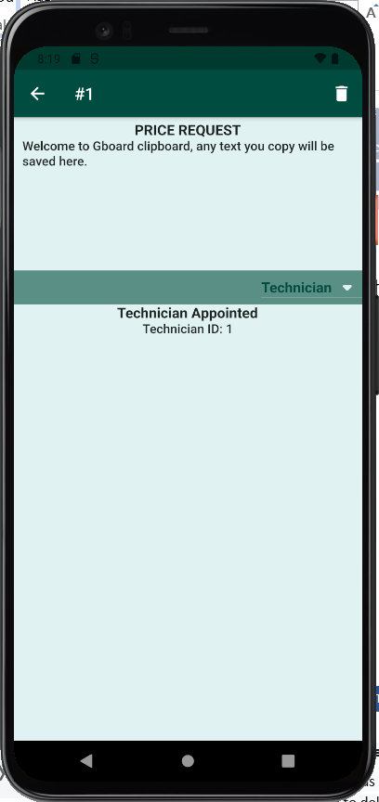

**2.1.2.5 Settings Screen**

**Update link to database**

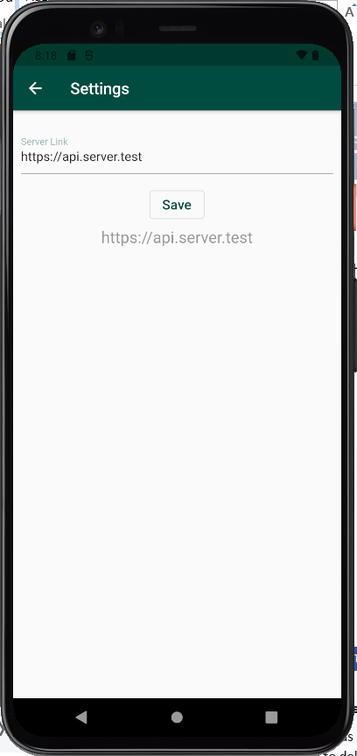

**2.3 General Functions**

* functions will be created to check login and direct to pending page
* manage all requests and allow users to add and to filter
* prepare settings where we can in future connect database
  + 1. **Tools to Use**
* Dart Languages
* Flutter platform
* Sqlite Database